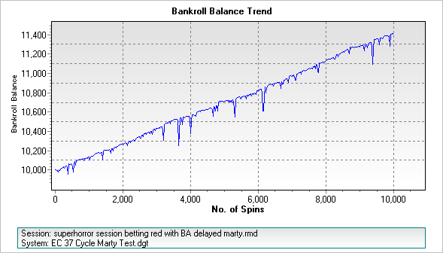
Max Drawdown = 437 Units
Largest Bet = 64 units

